**Portfolio**

**ENGKISH WRITING SKILLS AND COMMUNICATIONS**

**Semester: 2nd**



**Prepared and Submitted by:**

Name: Nokibul Arfin Siam.

ID: 21-44793-1.

Section: G.

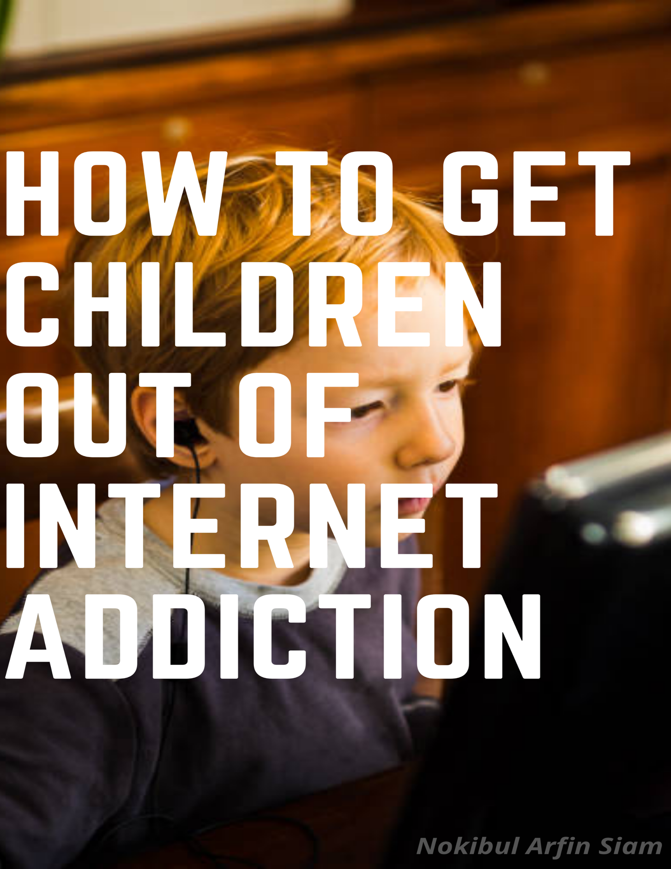

**Table of Content**

|  |  |  |  |  |
| --- | --- | --- | --- | --- |
| ***Sl*** | ***Task Title*** | ***Deadline for***  ***Submission*** | ***Date of***  ***Submission*** | ***Page No*** |
| 1 | Brainstorming & collect 3 relevant articles and take notes | Due 27 July, 2021 | 27 July, 2021 | 4-7 |
| 2 | Write the completed Outline of the essay | Due 27 July, 2021 | 27 July, 2021 | 8 |
| 3 | Write the revised and completed Outline of the essay & Write three body paragraphs and Conclusion by using sources | Due 15 August, 2021 | Due 15 August, 2021 | 9-11 |

**Essay Title: How to get children out of internet addiction**

1. **Brainstorming (Generating ideas):**

Some important prewriting techniques for gathering ideas are**- Brainstorming, Outlining and Mind mapping.**

**Brainstorming (Generating Ideas for Essay)**

Interest in reading books should be increased

Interest in sports should be increased

Discipline must be taught

How to get children out of internet addiction

Need awareness to the use of technology

Parents should give their children proper time

Encourage children to do the creative activities

The bad side of internet usage needs to be explained

Encourage children to do the social activities

**Collecting materials:**



Resource mat 1:[(PDF) The impact of internet and social media on the habit of reading books: A case study in the southern region of Bangladesh (researchgate.net)](https://www.researchgate.net/publication/324306578_The_impact_of_internet_and_social_media_on_the_habit_of_reading_books_A_case_study_in_the_southern_region_of_Bangladesh)

A piece of book is nothing but a lifeless object but it is obvious that a book can revive a mind. Reading books is the process that enriches one's mind with different branches of knowledge until one die. It creates new insight and new wisdom. Reading is one of the oldest habits of human civilization and is regarded as the passion of the greatest personalities of all times. To enrich knowledge, the most important task for everyone is to develop the habit and the culture of reading. One of the first documentary sources for reading was manuscript; however, it was accessible only to the elite class of society. Later, the arrival of the Gutenberg printing press ended such discrimination by making the printed word available to all. But it is a matter of great regret that reading habits are changing due to technological development over time. In this modern multimedia society, radio, television, cell-phone, computer and the Internet are consuming a big slice of time and reducing the amount of time spent on reading printed books. The amount of reading is declining significantly and reading skills are decreasing. Nowadays, children, youths and adults alike are inclined to use technology for information, entertainment and pleasure. The emergence of Internet has created an extraordinary change in the reading culture. It has made its existence, fully or partially, in the reading behavior of the people. Presently, because of the Internet revolution, reading sources have been transformed diversely into web sites, web pages, e-books, e journals, e-papers, e-mails, chat rooms, instant messaging blogs and other multimedia documents. Nowadays, Internet surfing enables people to navigate a world full of interconnected information, to discover new sites, to get up-to-date information and to download things of interest. Consequently, modern people have accepted Internet browsing as their daily habit and surfing the Internet has become a kind of addiction to the new generation. On the contrary, it is still believed that reading books, not browsing the Internet, is the best way through which one can travel upon the realm of knowledge and pleasure.

Notes:

1. Interest of reading books should be increased among the children.
2. Reading books can help children to learn many new things.
3. It is the only medium that can enlarge the knowledge of the children.
4. The habit of reading books will keep children away from internet addiction.

Resource mat 2: https://www.netnanny.com/blog/internet-addiction-in-kids/

One of the challenges kids face today is Internet addiction. Children who once lived for activities with friends, reading books, or watching TV are finding themselves addicted to the Internet, trapped in a mindset that places virtual activities above homework, real life social interaction, and even sleep. Many parents are searching for ways to help their children combat the intense desire to spend time online instead of in the real world. our children might be suffering with an addiction to the Internet if they seem anxious or absentminded when not using a computer, have lost interest in activities they previously enjoyed, stay up late to play games online or be on social networking sites, have irregular sleep patterns, have more virtual friends than real life friends, or neglect important school work to be online. If the children are suffering from an Internet addiction, first try finding out if they are spending so much time online to escape a problem. Those who are lonely, sad, bored, or angry will often go online to be distracted from their feelings. Move computers to a common area of the house and consider placing restrictions on where mobile devices that connect to the Internet can be used. Set a password for the computer so children cannot access the Internet without permission. Programs that help parents limit the time their kids can spend online are exceptionally helpful. There are some creative steps parents can take to keep their children’s online time reasonable in length. Mentioned by the news article are: Game Time Limit, an app that sets off an alarm when time limits have been reached on iPads/iPhones; Math Landers, a website that exchanges taking math quizzes for Internet access; and Minor Monitor, an app that tracks Facebook activities. No matter what steps is taken, know that there is hope. Parents should be a role model and limit the computer time. Use the resources and hope that the children will be on the road to recovery from their Internet addiction in no time.

Notes:

1. Not to stay up late to play games online or be on social networking sites.
2. Need awareness to the use of technology
3. Disciplined must be taught to the children.
4. The bad side of internet usage needs to be explained.

Resource mat 3: https://www.123helpme.com/essay/Analysis-of-Children-Internet-Addiction-330970

To prevent Internet addiction, it is a parent’s responsibility to raise their child(ren) on limited or no technology because parents and their children will not bond, it creates development problems, and technology becomes an abnormal necessity in a child’s life. One of the most important things to a child in today’s modern world would be technology. To them, it’s like honey to bees. Things like phones, computers, Facebook, and I-pods are owned by almost everyone in the world. Why this and how this has become a problem is still being argued in all parts of the world. It’s obvious that something must be put in action or limits on the amount of technology we use every day, should be enforced. It is true that technology has become a big part of society, but with its growth and development, people have started to forget morals, values and the old ways of life.  
Parents should raise children themselves with limited technology because parents and children will not bond. Today, it is very common to see a mother or a father sit their child down in front a T.V. and leave them for a few hours. If it is not that, they give them an I-pad of I-pod to play games in. I find it deplorable that people find it acceptable for parents to leave a child on end for hours coming back only to feed them. The only way people can truly bond and make connections is by spending time with each other. Parents have the responsibility to watch and care for their child in a loving way without the use of 24/7 technologies. Smart parents who are looking to raise healthy children would take this into serious consideration. I could understand watching a kid’s show every once and a while, but T.V. and Apple is not the only one can raise children.

Notes:

1. Parents should give their children proper time.
2. Encourage children to do the creative activities.
3. Create strong bond between parents and children.
4. Interest in sports should be increased among the children.

**How to get children out of internet addiction**

**Essay Outline**

1. **I. INTRODUCTION**
2. **II. BODY**
   1. **A. Body/ supporting Paragraph 1**

**Main Idea:****internet addiction causes anxiety, sadness, and depression.**

**Supporting Ideas -**

1. Sleep deprivation
2. Social isolation
3. Unable to keep schedules
4. Mood changes
   1. **B. Body/ supporting Paragraph 2**

1. **Main Idea:** **Create strong bond between parents and children.**

**Supporting Ideas –**

1. Parents should give their children proper time.
2. Encourage children to do the creative activities
3. Appreciate their good activities whatever it small or big
4. Taught them about good and bad sight in everything

**C. Body/ supporting Paragraph 3**

**Main Idea:**   **Increase their interest in sports**

**Supporting Ideas –**

1. Disciplined must be taught to the children.
2. Keep aware them to use technology
3. Have to learn to do their activities in time

**III. CONCLUSION**

***How to get children out of internet addiction***

The world has changed and evolved rapidly in the past few years. The invention of computer and modern internet has changed the fundamental needs of most children and teenagers. While computers are incredibly useful tools, they can also be addictive. Many kids have problems spending too much time on the computer, which can be frustrating for a parent. Internet addiction has been described as being just as powerful as a drug addiction and the child’s excessive internet usage could lead to more serious problems down the road. Although the Internet has become one of the most significant information resources for children, addiction to the Internet can negatively impact school performance, family relationships and children’s emotional state. ***But there is also some solution of this problem. If the Parents give their children proper time, they will not use internet addictively. Also, by telling them the bad side of internet usage. It can also get children out of internet addiction. Interest in reading books should be increased to solve this problem. To get children out of internet addiction encourage children to do the creative and social activities****.*

**First and most** **importantly, internet addiction causes anxiety, sadness, and depression.** Children who spend most of their time in the virtual world gradually withdraw from the real world. They soon become addicted to the internet to feel upbeat, accepted, and heard. And, when they are unable to access the Internet, they begin experiencing anxiety, sadness, and depression. Their studies and routine schedules are neglected. As a result, they suffer sleep-related problems like late sleep time, insufficient or restless sleep, and late waking time. It also causes insomnia. This sleep deprivation/disturbance can even worsen or magnify symptoms of anxiety and depression. According to the author Arun Sharma; Those who spend a lot of time on the internet tend to become a part of one or several online communities and have become isolated.

**Besides, to get children out of internet addiction it is very necessary to Create strong bond between parents and children.** First of all, Parents should give their children proper time. They should encourage children about the creative activities. Parents should also appreciate their children’s good activities whatever it small or big. By doing this parent are able to create a strong bond with their children. It can help children to overcome the internet addiction. It needs to make sure that children have time for other valuable activities, such as eating healthily, reading, homework, writing, physical activities, extracurricular activities, etc. Studies have shown that a British child spends an average of at least three hours a day on these screens. Norton European General Manager Nick S also said that raising children in modern times is not so easy. “It was once the job of parents to show if children played vegetables properly, went to sleep on time, or did proper schooling," he said. And now technical supervision is an additional matter of parental work at this time.”

**More importantly, to get children out of internet addiction interest in sport should be increased.** It is very necessary to taught discipline to the children. It is also very necessary to inspire them to play the outdoor games and admit them to any sports club. Also come in the company of nature. It is very important to take children in the company of nature. Play with the child in the garden or in nature. Play hide and seek, make a fuss, spend time. This will make children social. You can discover something new. Those who live in the city can take the child to nature one day a week or two days a month. This will improve your child's mental development. Young (1998) defined addictive Internet use as “an impulse control disorder that does not involve an intoxicant

**To conclude**, **the essay has sought to explore some of the solution of the interment addiction of the children.** At first, they need to be aware of the bad side of the internet. Also, it is very necessary to inspire them to do many social and creative activities. Also inspire them for reading story books and painting that will help children to decrease internet addiction. Keep children busy at home. Especially mothers can do this. You can tell your child, today you help me in this work. This will make your child interested in household chores and move away from mobile addiction. Finally, it should be very useful to creating opportunities where the children’s have access to positive recreational, sporting, communicating and cultural facilities where they can develop their mental health which may help them to overcome this problem.

**769 Words**

* + 1. [4 Ways to Stop Your Child's Computer Addiction - wikiHow](https://www.wikihow.com/Stop-Your-Child%27s-Computer-Addiction)
    2. [Internet Addiction in Children | Disabled World (disabled-world.com)](https://www.disabled-world.com/health/pediatric/internet-addiction.php)
    3. <https://centerforparentingeducation.org/library-of-articles/kids-and-technology/how-much-time-internet-kids/>
    4. https://www.parentcircle.com/the-negative-effects-of-internet-addiction-in-children/article